ECE 6: MADWEC 3.0 - Using Renewable Energy to Power Autonomous Underwater Vehicles

**Group Members:**

Spencer Dowty

Thomas Lattanzi

Antz-Lee Francois

Arthur Grizotte

**Sponsored by:**

Daniel MacDonald

Mehdi Raessi

**Advisor:**

Dr. David Rancour

**Report Submitted:**

September 28, 2021

**Table of Contents**

**Introduction** **2**

**System Description** **2**

**Customer Requirements** **6**

**Engineering Requirements** **7**

**Constraints and Standards** **10**

Constraints: 10

Standards: 11

**Ethical Issues** **11**

**Initial Estimates of Software, Equipment and Supplies** **12**

**Initial Plan and Schedule** **13**

**References** **16**

# **Introduction**

Marine energy has become a prominent source of the renewable energy sector over the past decade. The Maximal Asymmetrical Drag Wave Energy Converter (MADWEC) is a device capable of harnessing the kinetic energy from the ocean’s waves to generate an electrical output. The system is a small-scale and highly cost-effective platform with various applications in remote or deep-ocean locations. According to the Department of Energy, Autonomous Underwater Vehicles (AUVs) are a cheaper alternative to vessels for oceanographic measurements, monitoring, and surveillance; However, the power capacity of AUV batteries causes limitations to the device’s range and mission duration. The primary goal of the third iteration of the MADWEC is to prove its ability to serve as a charging station for these exploration devices. Docking and recharging stations would allow for an extension of a mission’s duration by prolonging the AUV’s effective range. “In the diverse, innovative technological environment of the Blue Economy, there are still no standards, regulations, or sets of best practices for underwater charging.” Therefore the objective of MADWEC 3.0 is to establish a universal standard for a variety of midsize AUVs.

# **System Description**

The MADWEC uses a tethered ballast that allows it to easily move down in the water column with open louvers. The louvers close as the device is pulled up in the water column and increase the added mass of the system, explaining the asymmetrical drag portion of the mechanism’s title. While the Power Take-Off (PTO) remains relatively stable around 50 meters below sea level, the buoy ascends with the oncoming waves. The buoy pulls a line that is attached to the PTO via guide arms and a reel. This reel translates the linear motion of the line into a rotational motion around a vertical axis. A shaft transfers this rotational motion through a water-tight bearing into the housing of the PTO. The shaft connects to a series of slip clutches, one-way bearings, flywheels, and power splitting gearboxes that connect to six 50 Watt generators. These generators provide electrical power and store energy in a battery bank after being rectified. This power is used to charge anything from autonomous underwater vehicles without having to pull them from the water.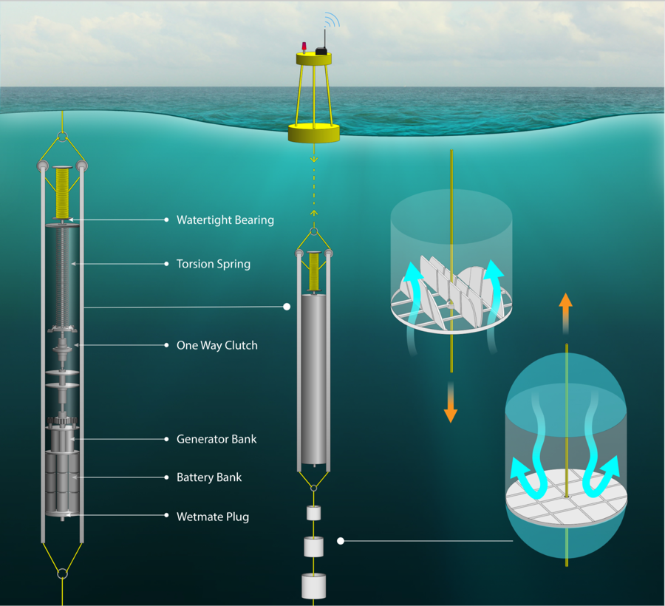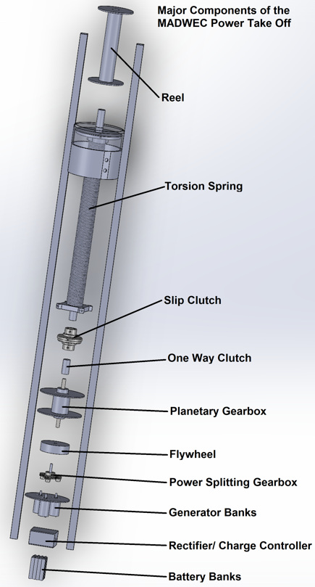

Figure 1: MADWEC 3.0 PTO System Design

The proposed docking mechanism in Figure 2 will be constructed and carried out by a team of mechanical engineers to be attached to the bottom-most ballast of the MADWEC, in line with the water column. When an AUV comes to dock with the station, the dock will turn to a 90-degree angle to allow for convenient docking for AUVs needing to recharge their battery. Once the chamber has an AUV inside, the station will fall into a vertical position to not create any additional drag and impede the power generation of the PTO. Figure 3 further exemplifies the intricacies of the system with a functional diagram. It is an overview of the interconnections 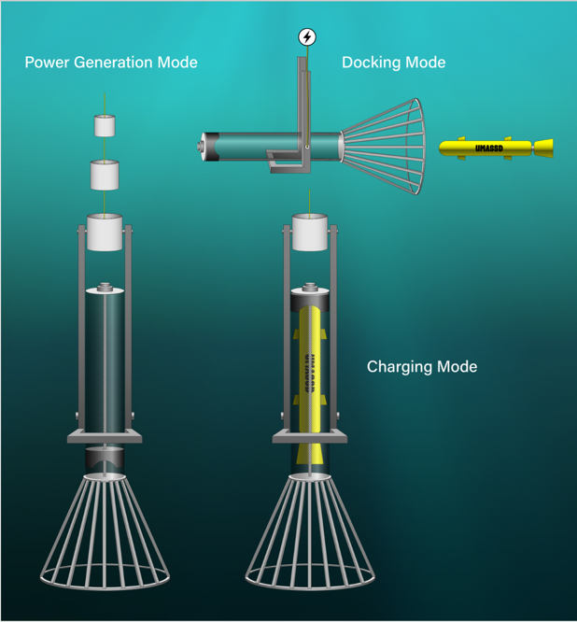between the two systems, simplifying the MADWEC to increase accessibility and understanding.

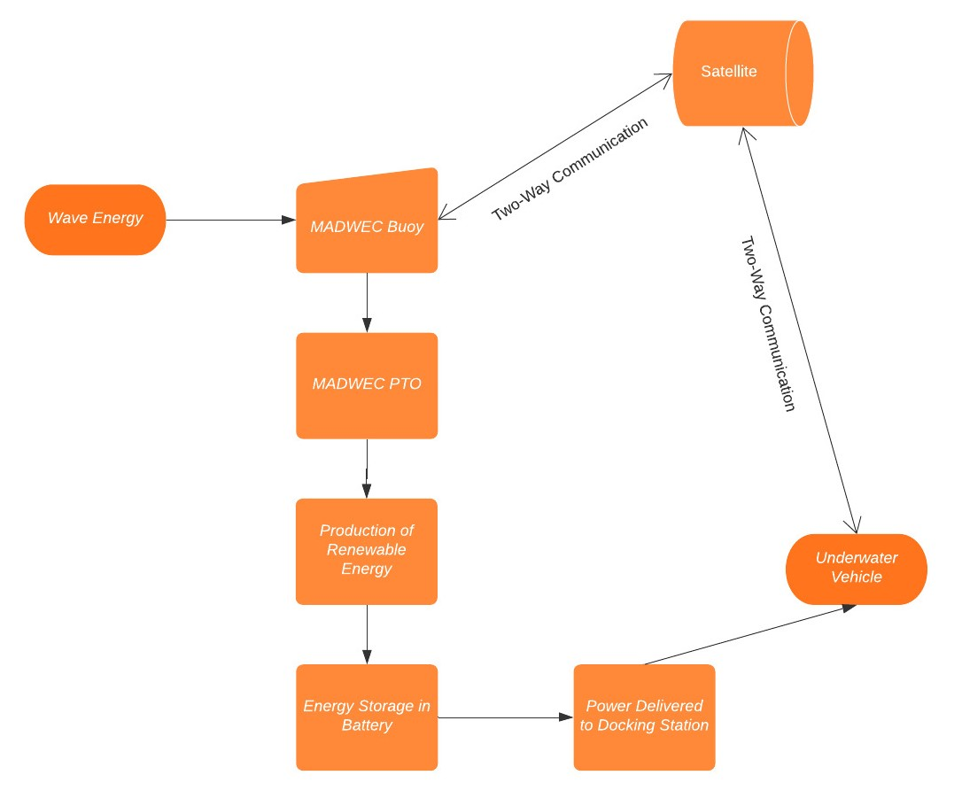Figure 2: MADWEC 3.0 AUV Charging Concept

Figure 3: MADWEC 3.0 System Diagram

# **Customer Requirements**

Table 1 contains the list of requirements for the MADWEC 3.0 put forth by the objective in the project proposal. These requirements were elaborated upon using the feedback given by the two sponsors of this project, Dr. MacDonald and Dr. Raessi, and the project advisor, Dr. Rancour. The purpose of this table is to provide a clear understanding of the customers' needs and demonstrate their vision for MADWEC in the future. These broad qualitative requirements will be further investigated from a technical perspective with more detailed, quantitative engineering requirements. These eight objectives should be carried out by the spring 2022 semester.

**Table 1: Customer Requirements**

| 1 | Design a charging station attached to the bottom of the MADWEC |
| --- | --- |
| 2 | Autonomous underwater vehicle must dock at the station horizontally |
| 3 | Charging should be compatible with a variety of different AUVs without requiring any alterations to the structure/hardware of the vehicle |
| 4 | Should accommodate at least one AUV with the potential for expansion |
| 5 | Determine a suitable battery to store the energy from the generators |
| 6 | AC/DC converter to adapt the electrical output of the MADWEC |
| 7 | Provide working winch to run “dry-testing” simulations in lab |
| 8 | Accessible design and integration for MADWEC 4.0 team |

The requirements stated will prove to be of great purpose when defining the engineering requirements. Requirement 1 directly relates to the system's function and overall goal. Requirement 2 gives a great understanding of the use of the system. Requirement 3 provides information on how different AUVs are going to be implemented making the system more versatile to different users. Requirement 4 describes how the MADWEC must be able to charge one AUV at a single time while also keep the idea of charging more than one simultaneously in mind. Requirement 5 depicts the challenge facing the students to determine a proper battery that suits the AUVs of choice and can charge them efficiently. Requirement 6 begins to get slightly more specific describing the system needed after the generators to get a stable DC signal to the battery. Requirement 7 indicates the task needed to run in-lab tests assigned by Geoffrey Souza at the SMAST East Lab. Requirement 8 ensures the students’ work is organized to provide accurate data for the next group working on MADWEC 4.0.

# **Engineering Requirements**

The engineering requirements are a quantitative version with subsections of the broad requirements given to the group by the sponsors of the MADWEC 3.0 project. These measurable values provide the electrical engineering group with attainable goals to achieve while designing portions of the MADWEC autonomous underwater vehicle charging system. Table 2 outlines the group’s engineering requirements tied to the customer requirements they stem from. In addition, a reliable test method consisting of inspection, analysis, demonstration, and testing is mentioned to ensure the successful completion of the engineering prerequisite. Some of these requirements may be subject to slight variation due to the design approved by the mechanical engineers.

**Table 2: Engineering Requirements**

| **Customer Requirement No.** | **Engineering Requirement No.** | **Engineering Requirement Description** | **Justification**  **and / or**  **Comments** | **Test Method**  **(IADT)** |
| --- | --- | --- | --- | --- |
| 1 | 1.1 | Device installation to withstand being located around 55 meters below sea level | How the charging station is interfaced with the MADWEC per sponsor request | Testing |
|  | 1.2 | Charging station should not interfere with power generation of the MADWEC | Maximize power stored in battery as the docking mechanism creates more drag | Analysis |
| 2 | 2.1 | AUVs must dock at a 90 degree angle to the MADWEC system | Accommodate for MADWEC’s orientation to allow for easier AUV docking | Demonstration/Testing |
|  | 2.2 | Mechanism should fall vertically, swinging at a -90 degree angle to minimize drag | This position would alleviate the additional drag forces introduced by the dock | Demonstration/Testing |
| 3 | 3.1 | Device Compatibility - Universal charging to power 2-3 different types of AUVs | Remus 100, Riptide UUV 7, Oceanserver IVER3, and Bluefin 9 all recommended | Demonstration/Testing |
|  | 3.2 | Accommodate chosen AUVs of ~9 inch diameter without requiring any alterations | To avoid any installation constraints by requesting changes to existing AUVs | Inspection |
| 4 | 4.1 | Charge at least one AUV while holding true to the average charge time of 6-8 hours | Guarantee full operation of MADWEC and allow AUV to run more missions. | Analysis  /Testing |
| 5 | 5.1 | Battery with 8kWh-10kWh capacity to store power from the six 50 W generators | More efficiently charge the AUVs while simultaneously not damaging the battery | Analysis  /Testing |
|  | 5.2 | Provide a continuous 5-10 Amps to the AUV during the charge duration | Crucial to recharging the AUV lithium batteries properly to ensure safety | Testing |
| 6 | 6.1 | Voltage regulator in order to step down/up and stabilize the AC signal from the generators rectifying it to 32 Volts DC | Need to regulate and stabilize voltage in order to charge the battery without any damage | Testing |
| 7 | 7.1 | Develop program to oscillate in-lab winch with 1-2 meter amplitudes and 8-15 second periods for PTO testing | Allow for more accurate data collection for output of the generators’ technical potential | Demonstration/Testing |
| 8 | 8.1 | Utilize obtainable software and hardware that will remain accessible for at least the next 3 years | Should not be obsolete within the near future since MADWEC is a long term project | Demonstration |

# **Constraints and Standards**

## **Constraints:**

The customer had not defined specific constraints for the team other than the docking and charging station must be tethered to the bottom of the MADWEC PTO device. The MADWEC 3.0 ECE students generated a list of constraints that they believe will restrict their progress. The first constraint is the budget. SMAST East had a stringent account that allocated the money to the MNE and ECE teams, giving them around $5,000 to work with. This is a constraint to the team because they are unsure whether they will obtain the full $5,000 budget or half that, as the other half maybe for the PTO team of MNE students. The ECE team also cannot get in touch with last year's MADWEC ECE students, withholding them from data and information from MADWEC 2.0. Another constraint deals with the collaboration between the MNE and the ECE teams. Working parallel together can be difficult to schedule meetings and times to work together due to clashing schedules. A big concern for the team is the constraint of limited lab space. This is due to a smaller, mechanical-based lab room at the SMAST East location. The ECE lab rooms at UMass are also closed due to construction. This will restrain the team from being able to run any lab tests and accumulate data for their project. There are also constraints relating to data, the students do not have a substantial amount of information on the outputs of the generators due to inconsistent wave patterns that were generated in the lab in previous years. This should no longer be an issue when the students complete the task of oscillating the in-lab winch. Finally, the MADWEC is to have limited alterations, which will hinder the team’s ability to make adjustments. This is because the MADWEC has already been partially built and set up in a lab room where not many changes to the previous designs and testing methods can be made.

## **Standards:**

Throughout the MADWEC 3.0 design process, there are many different standards and codes that the team must adhere to. Wet testing will be a difficult obstacle to overcome, so the team will be using the IP code of waterproofing, IP67, to guarantee the safety of components and continuous generation of power. The team will be creating a voltage rectifier PCB as well, which will adhere to the Institute of Printed Circuits standards, IPC-2221, to guarantee consistent use of the PCB. To safely use and store lithium-ion batteries, the team intends to follow IEC 62133-2 and OSHA 1926.441 to guarantee the maintainability of the MADWEC device. Maintaining safety in the lab and the field is of the utmost importance, so the team follows Underwriter’s Laboratory UL 817 Edition 11 standard for cord sets and power supplies. For even more safety in the lab, the team has also decided to follow the BS EN 61010 safety requirement for the laboratory use of electrical equipment. Finally, the team will be observing the entirety of the IEEE Code of Conduct.

# **Ethical Issues**

When it comes to finding an alternative Energy source, there are always other factors that may impede the progression of the project idea. When it comes to the MADWEC design there are certain environmental concerns as the design takes place in the ocean amongst other marine life. Therefore, the main ethical issue is towards the marine animals as the design might impede their way of life. Noise for instance is an important factor as underwater life relies heavily on sound and signals to detect their surroundings, so if the team were to design or use certain parts that increase the noise outputs, it may affect marine life in the ocean. To prevent such issues, measures need to be taken to absorb noise vibrations from gears and motors/generators.

Other concerns revolve around the rechargeable batteries where they need to be securely encased so that water doesn't enter the system, as water can react intensely with lithium batteries. Ultimately raising concerns for encasing the entire system, not leaving open slots to allow smaller wildlife to inhabit the MADWEC, and preventing any spillage from the batteries/lubricating fluid within the system. The lubrication fluid within the system primarily would focus on the motors, the one-way clutch, and potentially the rotating docking station for the AUVs. Due to the lubrication being housed in different aspects of the MADWEC, these locations must be enclosed to prevent any more environmental concerns. Lastly, other concerns would be towards losing parts of the unit or the entire unit as a whole. To prevent such measures, the different parts of the MADWEC can be broken down into sections that contain GPS trackers that can always have the locations of the units. Therefore, if the charging docking station that is located at the bottom of the MADWEC is somehow detached due to an AUV strike or high intense wave, the GPS tracker can locate and allow for its retrieval before impacting the marine life surrounding it.

# **Initial Estimates of Software, Equipment and Supplies**

The MADWEC 3.0 will require software that is already paid for by the University of Massachusetts Dartmouth. This software includes EAGLE/KiCAD which will be used to produce schematics for systems such as the voltage regulator, and the system diagram of the entire system. EAGLE/KiCAD will also be used for any PCB designs that need to be utilized throughout the process. Microsoft Visual Studios will be used for processor programming and MATLAB can simulate oscillations and amplitudes along with analyzing data files. At this point, the students are unable to estimate the cost of the hardware components for the MADWEC 3.0 due to limited communication to last year's team as well as the open-ended aspect of this project. Since we are responsible for the second objective in the provided project description, our equipment will rely heavily on the decisions of the Mechanical Engineers. Cost estimation and more specific hardware requirements will become more prominent as the project progresses with definitive estimates within the next month. The electrical engineering students have put together a soft list of hardware components for the time being with the requirements given to them at this time. This list of hardware components consists of components for the voltage regulator, a battery bank, step motors for the docking system, a charging plug for the AUVs, and a transponder. Depending on the scope of the mechanism designed by the mechanical engineers additional commercial off-the-shelf (COTS) components may be added to this list. Per the sponsor’s request, “Ideally, most MADWEC components will be designed to prioritize cost reduction and use existing technology and commercially available off the shelf (COTS) components as much as possible.”

# **Initial Plan and Schedule**

The project schedule follows the GANTT calendar template which is a bar type chart illustrating a project’s schedule. In regards to the schedule of the MADWEC project, our team followed the course syllabus that was provided at the beginning of class. Therefore, the schedule consists of important deadlines such as presentation deadlines, report deadlines, and concept benchmarks. The schedule demonstrates completed tasks and meetings that the ECE MADWEC team has already done. As of now, the schedule is separated into 3 months, following the semester, to show a list of tasks that the team has and still will accomplish.

## Figure 4: MADWEC 3.0 Project GANTT Schedule

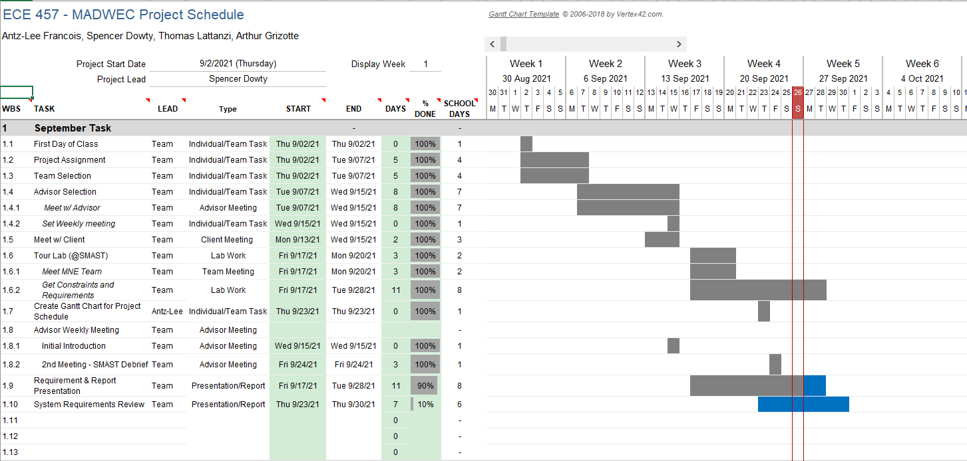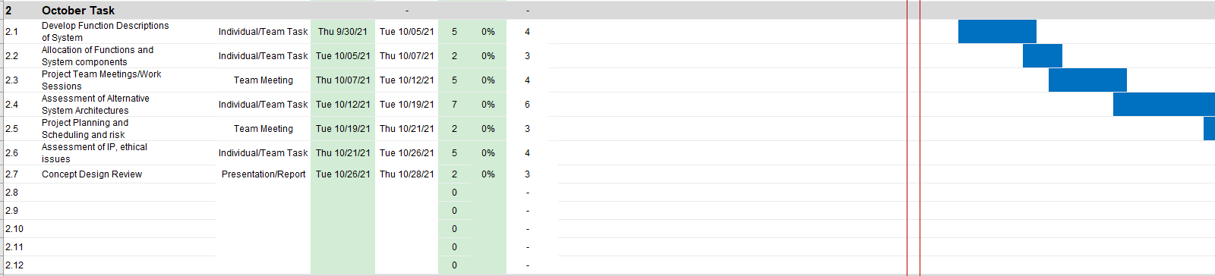



With that, it's important to note that the schedule only consists of the tasks of the ECE team, not the MNE team. There is some integration between the teams but that is separated by the “Type” of task (*Team Meeting, Advisor Meeting, Client Meeting, Lab Work, Presentation/Report, Individual/Team Task*). With the Gantt schedule, it helps the ECE team better visually understand the deadlines that the team has and the progress that the team has made. In regards to next steps, the ECE team plans to continue having weekly meetings with the team advisor to still keep them updated and get better understanding. As for meeting times, the team is in the process of creating meeting times with the MNE Team, Client, and SMAST Lab so we can always be on the same page. Further, the group is currently responsible for meeting with AUV manufacturers to obtain specifications for an acceptable charging protocol. While a meeting at the Wood’s Hole Oceanographic Institute (WHOI) has already been scheduled to discuss the Remus-100, a few more companies have not yet responded to the team’s inquiry request. Such unforeseeable meetings will be updated into the schedule after they occur.

# **References**

“Applying IPC Standards to PCB Layout Design.” *Cadence: PCB Design and Analysis*, https://resources.pcb.cadence.com/blog/2021-applying-ipc-standards-to-pcb-layout-design

“Department of Transportation: Transportation of Lithium Batteries.” *AUVAC*, Department of Transportation, https://auvac.org/files/fdsys/pkg/fr-2014-08-06/pdf/2014-18146.pdf.

“Gantt Chart Template for Excel.” *Vertex42*, https://www.vertex42.com/ExcelTemplates/excel-gantt-chart.html.

“IP Rating Chart.” *DSM&T Harsh Environment Connectors and Wire Harnessing,* https://www.dsmt.com/resources/ip-rating-chart/

“Lithium-Ion Battery Standards.” *USAID*, International Electrotechnical Commission, https://www.usaid.gov/energy/powering-health/technical-standards/lithium-ion-batteries

“Massachusetts Renewable Energy Requirement.” *Colonial power Group,* https://colonialpowergroup.com/massachusetts-renewable-energy-requirement/

“REMUS 100h - Hydrographic Variant.” *HII Technical Solutions*, 23 Mar. 2021, https://tsd.huntingtoningalls.com/capabilities/unmanned-systems/unmanned-underwater-vehicles/remus100variants/remus100h/.

“Standards for Electrical Test Instruments and Test Leads.” *Electrical Safety*, [https://elecsafety.com/standards-for-electrical-test-instruments-and-test-leads/](https://elecsafety.co.uk/standards-for-electrical-test-instruments-and-test-leads/)

“System Diagram.” *Lucid Chart: Intelligent Diagramming,* https://www.lucidchart.com/pages/

“The Mysteries of IP65, IP66, and IP67 Rated Enclosures Explained.” Bud Industries, https://www.budind.com/blog/2014/02/the-mysteries-of-ip65-ip66-and-ip67-rated-enclosures-explained/

“[1926.441 - Batteries and battery charging.” *Occupational Safety and Health Administration*](https://www.osha.gov/laws-regs/regulations/standardnumber/1926/1926.441),

<https://www.osha.gov/laws-regs/regulations/standardnumber/1926/1926.441>